2D Collision Detection – Research and Game Prototype Project

By: Aidan Kilpatrick
Course Name: Game Engine Foundations
Instructor: Leonardo Ribeiro de Moura
Date: November 11th, 2025
Contents
Screen Shots 3
Report 3
1. What is Collision Detection? 3
2. AABB–AABB vs. AABB–Circle Detection 3
3. Diagrams Explained 4
4. The Importance of the Clamp Function 5
References 6

Report

1. What is Collision Detection?
In my own words, collision detection is the mathematical process of checking whether two or more game objects are currently occupying the same space, or whether their paths will intersect in the next frame. It is the first step in creating physical interaction between objects in a game world.
Collision detection is typically handled in two distinct phases:
- Broad Phase: Quickly ruling out objects that are nowhere near each other.
- Narrow Phase: Performing a precise check on the remaining objects.
Why Simplified Shapes are Used
Developers almost always use simplified geometric shapes (like circles, rectangles, and spheres) instead of an object’s complex, detailed mesh for collision detection for one main reason: performance (speed).
A game object’s "real mesh" (its detailed visual model) might contain hundreds or thousands of vertices and triangles. Checking for intersections between two complex meshes is mathematically intensive and slow.
In contrast, simplified shapes, known as bounding volumes (like Axis-Aligned Bounding Boxes or AABBs, and bounding circles), are extremely fast to compute because they require only a few variables (e.g., minimum and maximum coordinates, or a center and a radius). This allows the game to run dozens or hundreds of thousands of collision checks per second without slowing down the frame rate.

2. AABB–AABB vs. AABB–Circle Detection
The core difference between these two methods lies in the mathematical checks required:
AABB–AABB (Axis-Aligned Bounding Box to Axis-Aligned Bounding Box)
This is the simplest and fastest method. It checks for overlap along each axis (X and Y) independently. A collision occurs only if the objects overlap on both axes simultaneously.
Pseudocode for AABB–AABB Collision Check:
function CheckCollisionAABB(RectA, RectB):
// Check for overlap on the X-axis
collisionX = RectA.Max.X >= RectB.Min.X AND RectB.Max.X >= RectA.Min.X

// Check for overlap on the Y-axis
collisionY = RectA.Max.Y >= RectB.Min.Y AND RectB.Max.Y >= RectA.Min.Y

// Collision occurs if overlap exists on both axes
return collisionX AND collisionY

AABB–Circle (Axis-Aligned Bounding Box to Circle)
This method is more complex because a circle's shape is not defined by axes. Instead, it relies on calculating the closest point on the rectangle to the circle's center. A collision occurs if the distance between the circle's center and this closest point is less than the circle's radius.

3. Diagrams Explained
Since I cannot draw a traditional diagram, I will use descriptive language and a simple structural representation to illustrate the geometry of the concepts.
Diagram A: AABB–AABB Collision Overlap
Imagine two rectangular bounding boxes, Box A and Box B. The collision is defined by ensuring the end of one box does not fall before the beginning of the other box along a single axis.
X-Axis Overlap Check:

[ B.Min.X ] <---------> [ B.Max.X ]
| |
|------------|----------|------------------|------------|
0 A.Min.X A.Max.X Screen Width

Overlap on X is true if: (A.Max.X >= B.Min.X) AND (B.Max.X >= A.Min.X)

If this condition is true for the X-axis, and the same condition is true for the Y-axis, the collision is confirmed.
Diagram B: Closest Point for Circle–AABB Detection
For the circle-AABB detection, the goal is to find point P on the rectangle's border that is nearest to the circle's center C.
The calculation works like this:
- Define Rectangle Edges: The X-coordinates of the rectangle range from R_{min.X} to R_{max.X}. The Y-coordinates range from R_{min.Y} to R_{max.Y}.
- Find the Closest Point (P): The coordinates of P are calculated by clamping the circle's center coordinates (C_{x}, C_{y}) to the range of the rectangle's coordinates.
- Check Distance: Once P is found, calculate the distance between P and C. If Distance(P, C) <= Radius, a collision has occurred.

4. The Importance of the Clamp Function
The clamp function is a mathematical tool that limits a value to a specified range (minimum and maximum).
The clamp function takes three arguments: clamp(value, min, max).
The result is:
- min, if value is less than min.
- max, if value is greater than max.
- value, if it is between min and max.
Role in AABB–Circle Detection
The clamp function is critically important in AABB–Circle detection because it efficiently finds the closest point on the rectangle to the circle's center.
In the code we used, Math.Clamp is applied to the ball's center coordinates using the rectangle's edges as the min and max limits:
P_{closest.X} = clamp (C_{ball.x}, R_{min.X}, R_{max.X})
P_{closest.Y} = clamp (C_{ball.Y}, R_{min.Y}, R_{max.Y})
- If the ball is directly above the rectangle, the X-coordinate of the closest point will be the same as the ball's X-coordinate. The Y-coordinate will be clamped to R_{min.Y} (the top edge).
- If the ball is far to the left of the rectangle, C_{ball.x} will be less than R_{min.X}, so the result will be R_{min.X} (the left edge).
By applying clamp to both axes, you guarantee that the calculated point P_{closest} is the absolute closest point on the rectangle to the circle's center, which allows you to accurately measure the penetration distance with the ball's radius.

Screen Shots

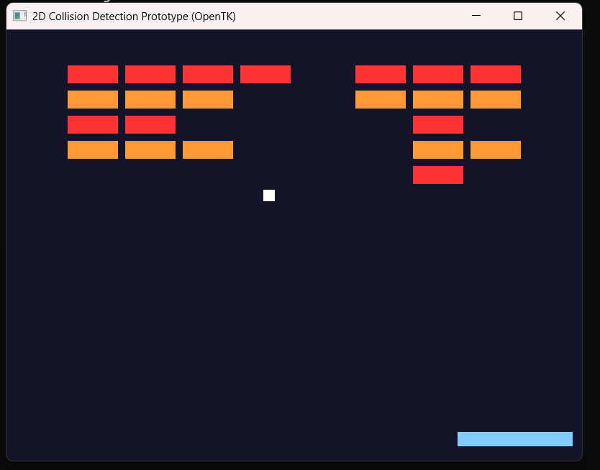
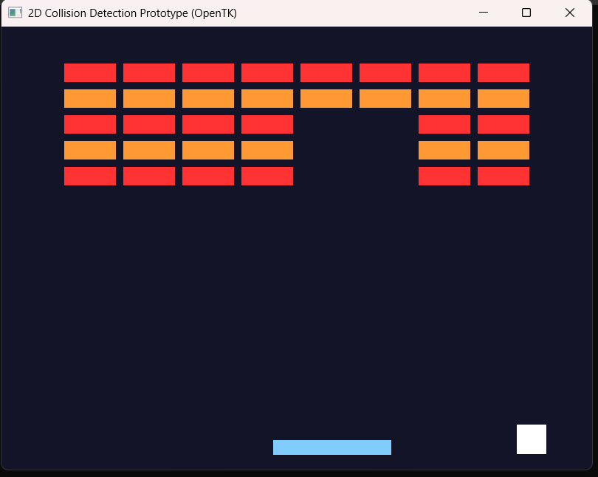
different ball size

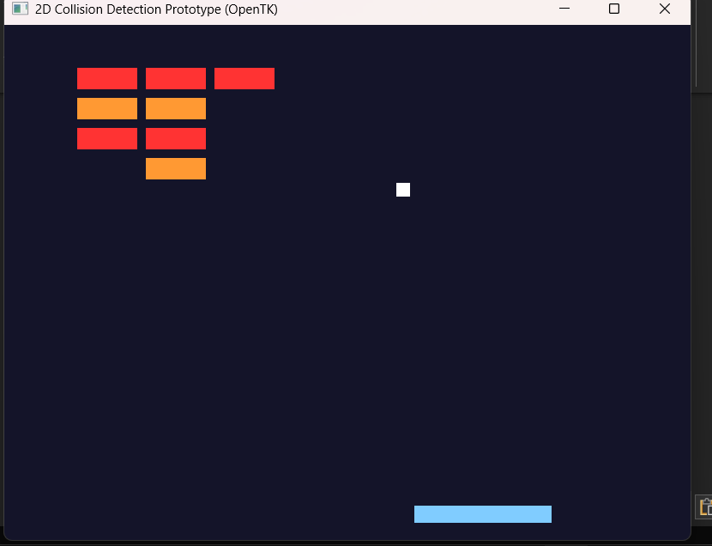
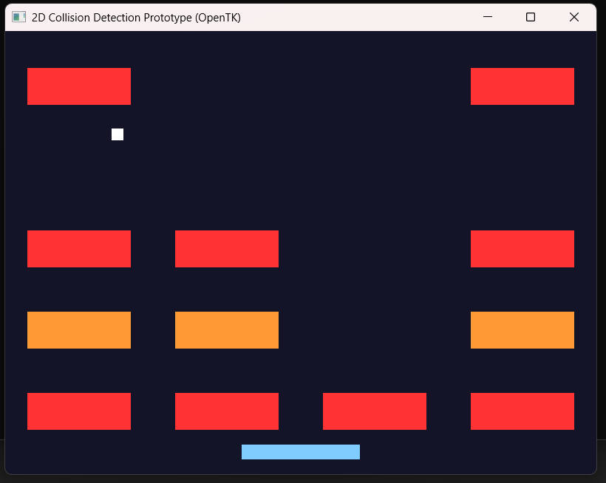
Changed brick size to be bigger and padding to be more
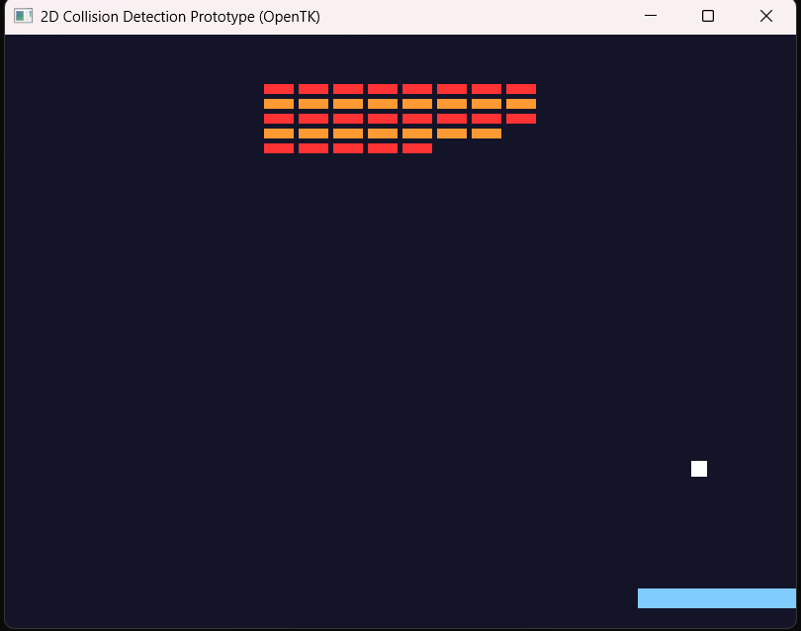
Changed brick size to be smaller and padding to be less

References

Collision detection. LearnOpenGL. (n.d.). https://learnopengl.com/In-Practice/2D-Game/Collisions/Collision-detection

